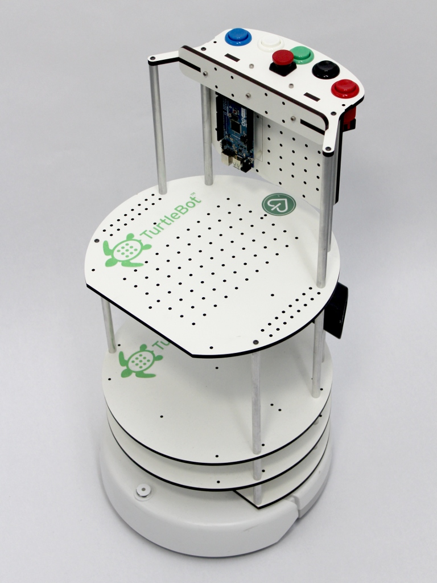


Buttons Mount and Buttons Shield Kit
Includes
- 5x Competition grade arcade buttons
- 1x E-stop button
- Mounting hardware
- MDF Mounting Plates
- Wiring for buttons
- 1x Buttons Shield
- Stacking Headers sold separately

http://www.IHeartEngineering.com

Description
The Buttons Mount has holes for 5 large arcade push buttons and 1 emergency button (e-stop) on top of the TurtleBot. The mounting plates have holes to support an Arduino Uno, Arduino Mega or any other Arduino board with similar mounting holes specifications. The Buttons Shield stacks on top of the Arduino board and has snap-on connectors for the buttons wires. Each button can be configured to do a different navigation task using serial communication or the ROS rosserial stack to communicate with the Arduino board.

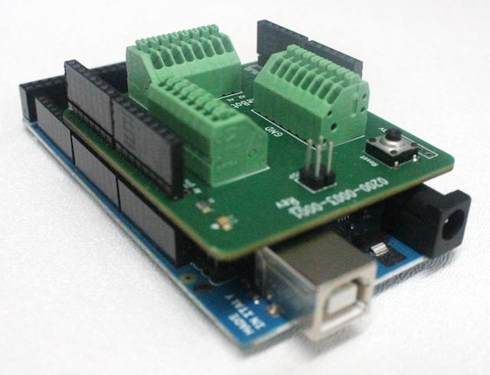
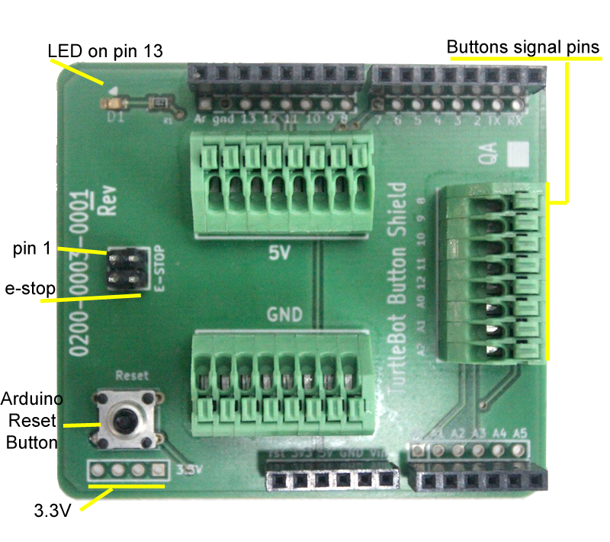
Shield Stacking
The TurtleBot Power Interface Shield can be stacked on the Arduino Uno, Arduino Mega, Arduino Duemilanove, and other Arduino boards with similar specifications.

Soldering
Solder stacking headers to stack the shield to an Arduino board. Place the stacking headers from top to bottom and turn the shield upside down as seen on the picture. Solder one pin at a time applying enough heat and solder.
If using regular header pins (non-stacking), place the pins on the Arduino Board first. Then, stack the shield on top and solder from the top side. That way the pins remain aligned with the Arduino Board.
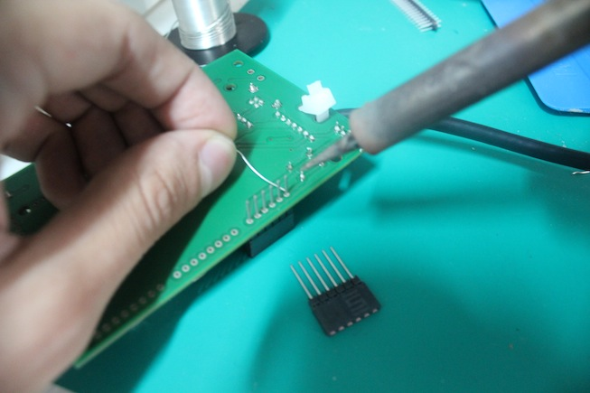

Assembling Mount
Screw the four aluminum rods on top of the highest TurtleBot plate. Then, attach the MDF plates together using nuts and screws on the t-shaped perforations. Screw in the Arduino board mount pieces and attach the Arduino with four screws. Assemble the buttons and connect the buttons wires to the shield before screwing the mounting boards on top of the aluminum rods.
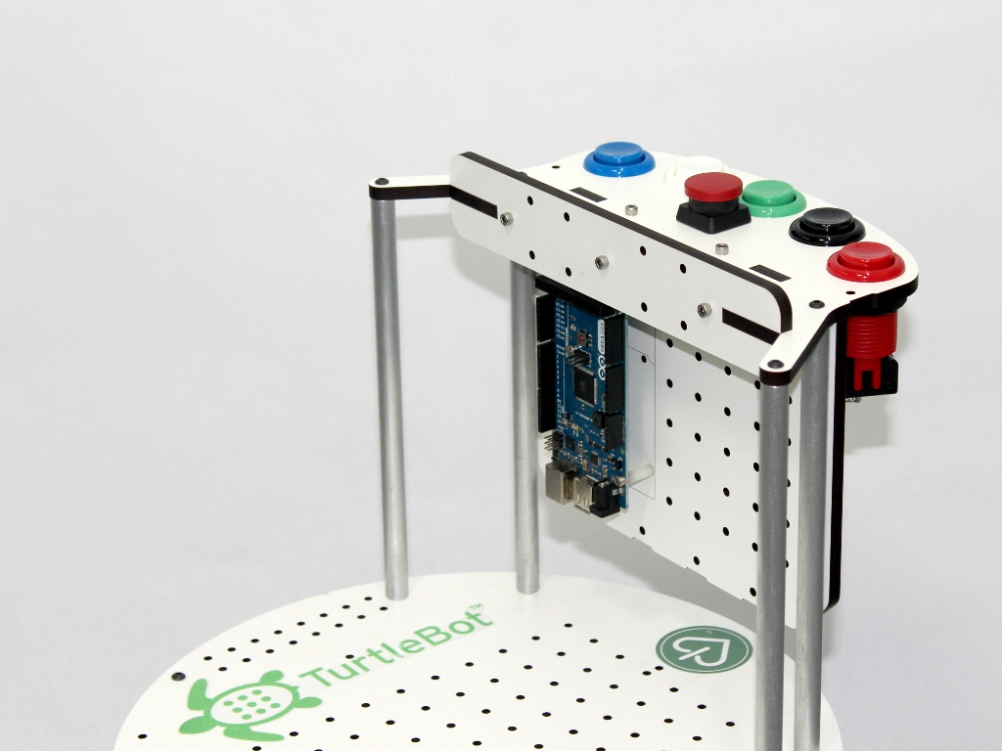
Assembling Buttons
Connect the stripped end of the wires to the snap on connectors on the Buttons Shield. Use the black wires for ground, red wires for 5V, and white wires for signal inputs. Twist the end of the wire so that the threads stay packed together. Use a small flat screwdriver to push in the secure pin on the snap connector. Place the end of the wire in and release the secure pin. Make sure the wire is secured in place. Repeat the process for each wire.

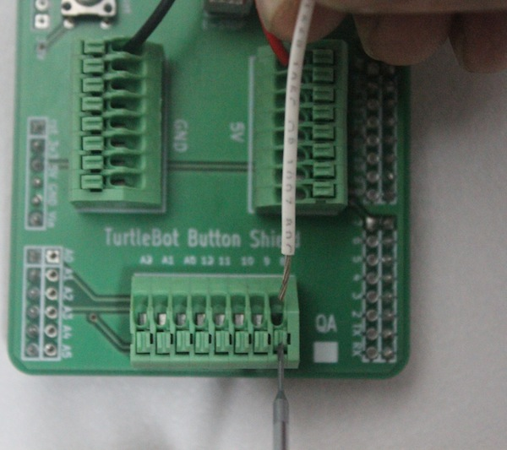

The provided arcade buttons consist of two main parts: the color screw cover with a spring mechanism inside, and the momentary switch inside a black box. To separate the two parts, look at the longest pin on the color cover that holds the black switch. Push that pin out of the hole on the black switch with a flat screwdriver. Then rotate the black switch and pull it gently apart of the color cover. Reverse the process to put the two pieces back together.

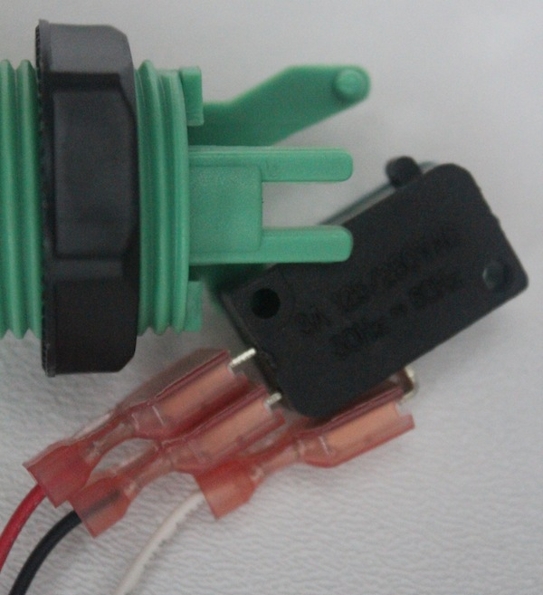

Connect the red and black wires to the Normally Open (NO) and Normally Closed (NC) pins respectively in the black switch. Connect the white wire to the Common pin. Take into account that the NO pin will be connected momentary to the Common pin when the button is pressed. In the described connection, the button state will go high when the button is pressed. It will be low at any other moment.

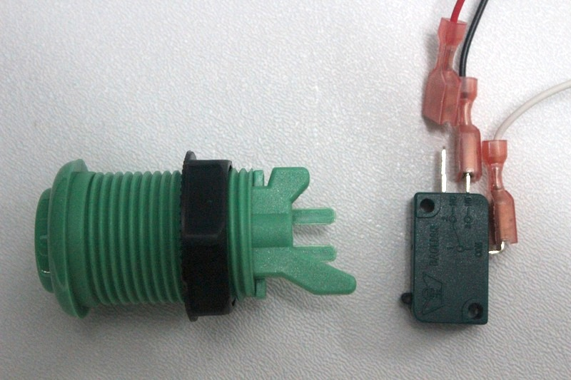

The e-stop switch is a DPST switch. The e-stop connector has a shroud with a key. The red wire indicates pin 1. Connect the e-stop wire on the shield with the key facing outwards. Pin 1 is properly labeled on the shield and is tied to the Arduino digital pin 7. Pin 3 is tied to 5V. Pins 2 and 4 are left without connection so that the end user can attach another circuit to detect if the e-stop is pressed.
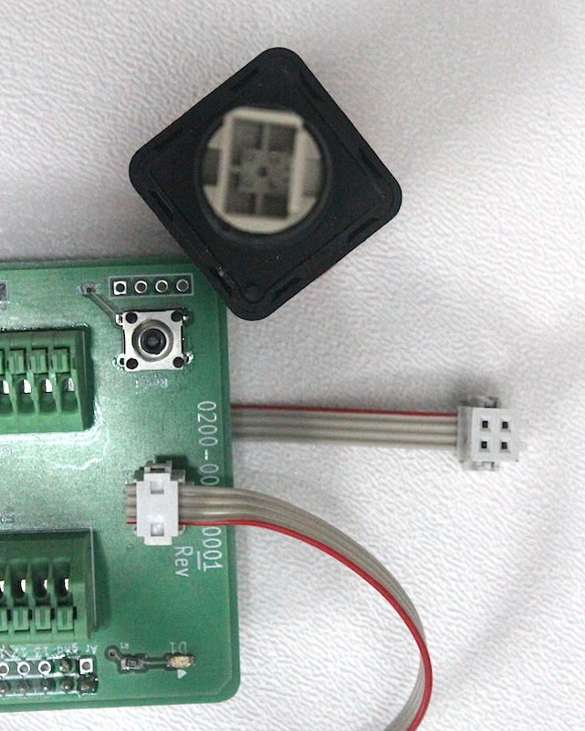
Note: On the Buttons Shield Rev. 02 the four e-stop pins are broken out in the shield.

Screw off the black nut of the button cover before putting the switch and cover back together. Place the button cover through the button hole on the mounting plates. Screw back on the black nut until button is tight in place. Do the same for the e-stop button.
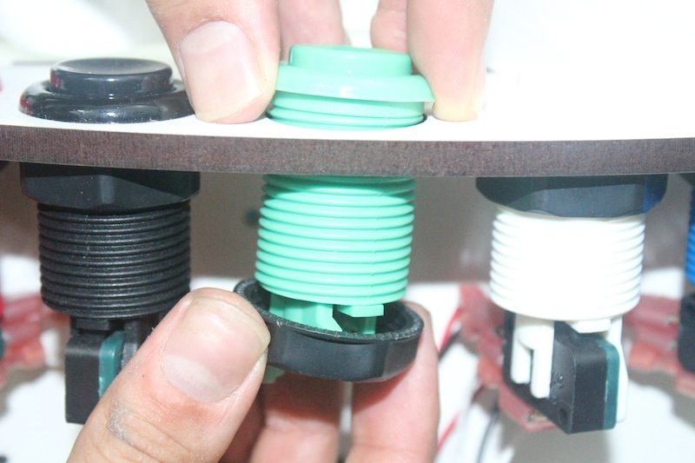
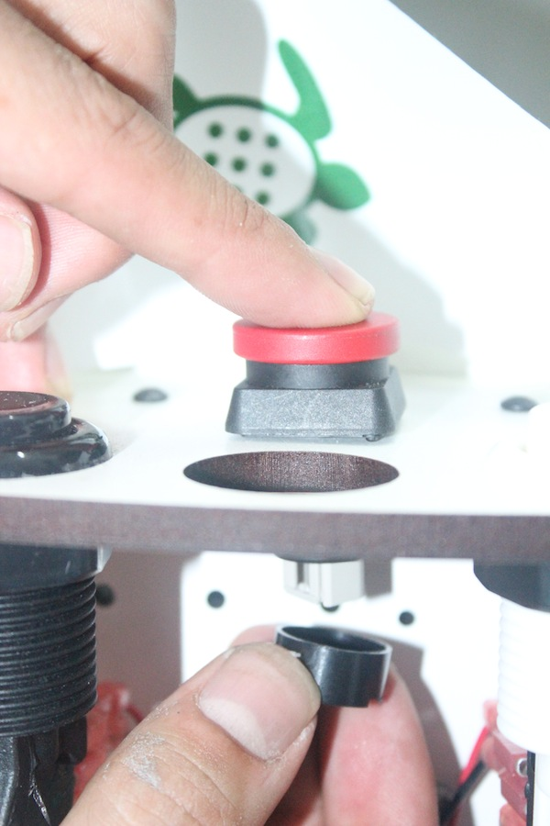
Place back the switches on their respective covers and connect the e-stop. Stack the Buttons Shield to the Arduino board and screw the Buttons Mount on the four rods on the TurtleBot.
Pull Down Resistors
To avoid floating voltages on the e-stop, solder a 1k Ohm or higher value resistor between pin 7 and ground. Avoid contact between the resistor legs and any exposed copper pins.
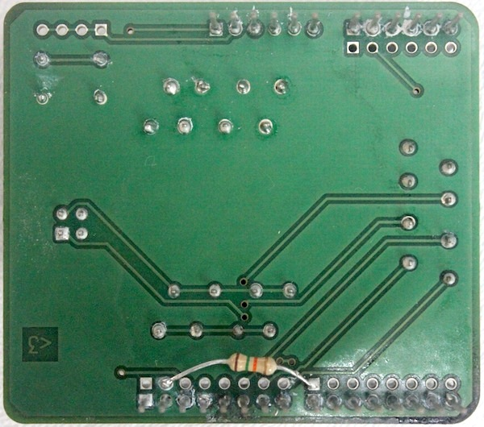
Note: Buttons Shield Rev. 02 has drop-down resistors on every button input pin. Thus the black wire is not necessary. The red (5V) wire must be connected to the NO pin and the white (signal) wire must be connected to the common pin on the switch.
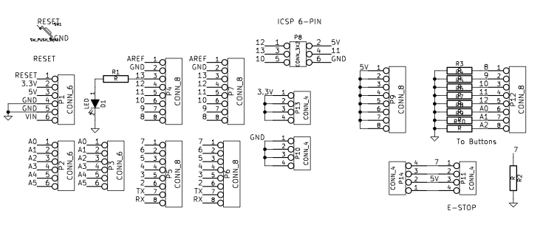
Buttons Shield Rev. 02 Schematic
Tech Support
For any problems, questions, or comments feel free to contact an I Heart Engineering representative via email at support@iheartengineering.com or phone.

License
The FreeBSD Documentation License
http://www.freebsd.org/copyright/freebsd-doc-license.html
Copyright 2012 I Heart Engineering. All rights reserved.
Redistribution and use in source (SGML DocBook) and 'compiled' forms (SGML, HTML, PDF, PostScript, RTF and so forth) with or without modification, are permitted provided that the following conditions are met:
Redistributions of source code (SGML DocBook) must retain the above copyright notice, this list of conditions and the following disclaimer as the first lines of this file unmodified.
Redistributions in compiled form (transformed to other DTDs, converted to PDF, PostScript, RTF and other formats) must reproduce the above copyright notice, this list of conditions and the following disclaimer in the documentation and/or other materials provided with the distribution.
THIS DOCUMENTATION IS PROVIDED BY I HEART ENGINEERING "AS IS" AND ANY EXPRESS OR IMPLIED WARRANTIES, INCLUDING, BUT NOT LIMITED TO, THE IMPLIED WARRANTIES OF MERCHANTABILITY AND FITNESS FOR A PARTICULAR PURPOSE ARE DISCLAIMED. IN NO EVENT SHALL I HEART ENGINEERING BE LIABLE FOR ANY DIRECT, INDIRECT, INCIDENTAL, SPECIAL, EXEMPLARY, OR CONSEQUENTIAL DAMAGES (INCLUDING, BUT NOT LIMITED TO, PROCUREMENT OF SUBSTITUTE GOODS OR SERVICES; LOSS OF USE, DATA, OR PROFITS; OR BUSINESS INTERRUPTION) HOWEVER CAUSED AND ON ANY THEORY OF LIABILITY, WHETHER IN CONTRACT, STRICT LIABILITY, OR TORT (INCLUDING NEGLIGENCE OR OTHERWISE) ARISING IN ANY WAY OUT OF THE USE OF THIS DOCUMENTATION, EVEN IF ADVISED OF THE POSSIBILITY OF SUCH DAMAGE.

